|  |  |
| --- | --- |
|  |  |
| Technical Document |  |
|  |  |
|  |  |
|  | Batjari Elmir |

|  |  |  |  |
| --- | --- | --- | --- |
|  | IntroductionThe goal of this project is to have several servers with a client that communicates with each other. Each server and client executes a script. The client connects with the ip and the port and can execute commands asynchronously. In addition it contains a graphical interface.  **The server part.**  This part was done as follows:    In this code everything is played in syntax each step allows to do a certain action which leads to a stop when the condition for example kil is met.  This allows the listener to receive and send commands.  It also fulfills the kill reset and dis connect conditions.    This part is used to send a give to the client so that it closes which prevents me from having errors and closes the client correctly. | |  |
|  | Function part of the commands:      All this part I define functions allowing me to call later.  To call this function I create the execute function which allows me to structure all its correctly and make sure that just this command is readable. | |  |
|  | The customer part: I created two class there class which allows me to have a connection of a server but unique it is to say it will have just the characteristics of the port and ip just has it which allows me thereafter to develop several servers at the customer.  This class contains: | |  |
|  | My interface for writing therefore controls the tab that opens.  Sending message:  Allows you to send the message and display it on the interface.  Receive orders: |  |  |

Receives commands from the server and if I receive a disconnect it resets and disconnects and closes the client.

The second class for the connection and csv:

Port and IP connection:

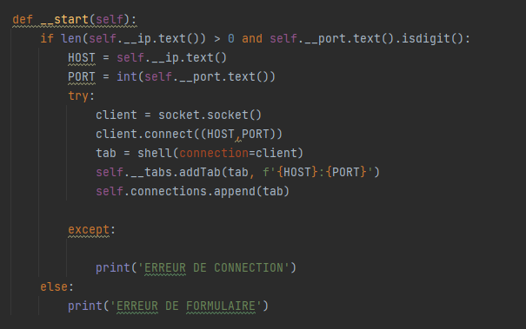

Allows you to connect to the server that is listening.

CSV :

I open by default a csv file where inside we will put the different ip and server port by hand afterwards it will be displayed in the csv tab.